Email: emtiaztafsir@gmail.com
Title: Online Doctor Appointment System
Download APK

Project Features:
- Multi user type
- Login system
- Registration
- Creating profile
- Realtime Database
- Finding Nearby Doctors (For Patients)
- Request for Appointment (For Patients)
- See all appointments and their status (For Patients)
- Communicate with doctors who have accepted Appointments (For Patients)
- See pending Appointment requests (For Doctors)
- Choose Action for pending appointment (For Doctors)
- See active/accepted appointments (For Doctors)
- Communicate with patients (For Doctors)
- See chat history (For both types)

- Multi user:
This app has two types of user base. One being the doctors and the other being the patients or general user. Upon registration, the app prompts to create a profile to the user. The user can choose a type and that information is saved on the database. After that, every time an existing user logs in, the app evaluates the user type and sends them to their proper activity.

- Login system:
After launching, the app checks for authentication, determining if a user is logged on or not. If not, it launches the Login Activity. The login screen consists of an email field, a password field and a submit button. It also holds a link to the registration page for new users. After pressing the submit button, the app checks if email and password is empty or not. If empty, it shows an error message. If not, it further checks for proper email format and minimum password length. Sets error if any rule is violated. Once all rules are passed, the app initiates authentication. The login page consists a hidden progress bar and a progress status. If any error occurs during authentication, the progress status informs the user about it.
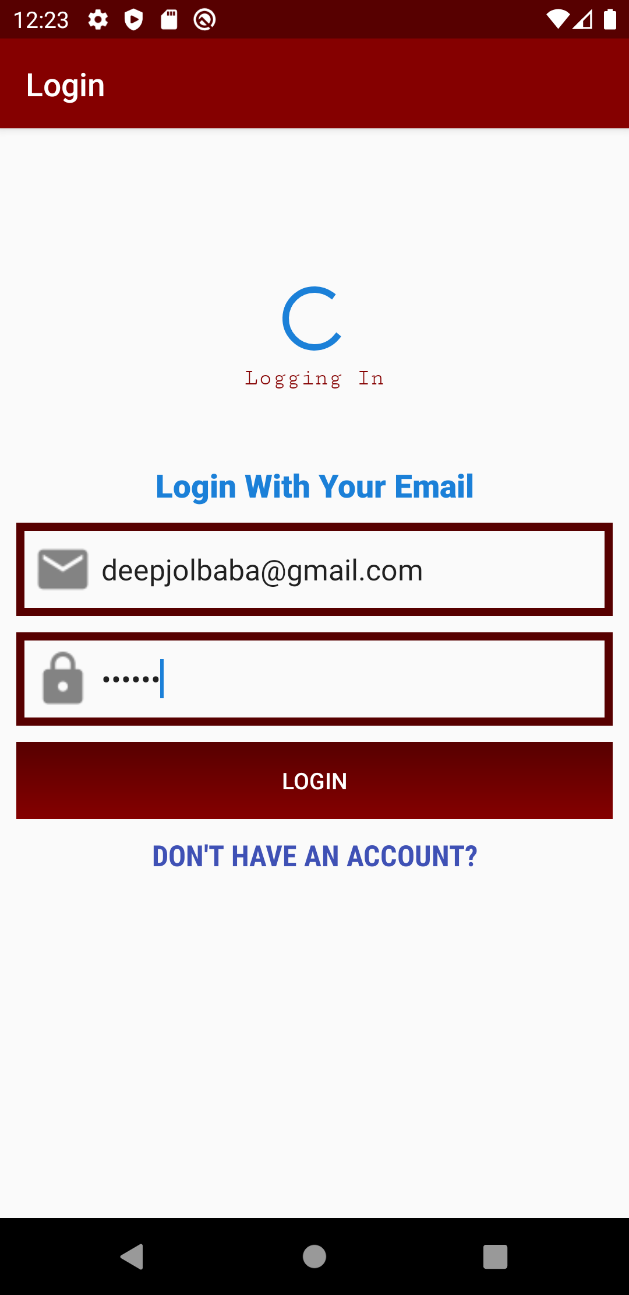

- Registration:
The registration page consists of 3 EditText fields and a Register Button. The fields are Email Address, Password and Confirm Password. Upon clicking the Register Button, the app validates the email and password using the same rule as the login activity. Additionally, it checks if both passwords match with one another. If no rule is violated, the app sends registration request to the server. This page also has a hidden progress bar and status field. Both of them becomes visible when the request is sent. If any error occurs (like duplicate email address), the error message is shown to the user. If registration is successful, the app reverts to the login activity with the proper information and automatically initiates authentication.

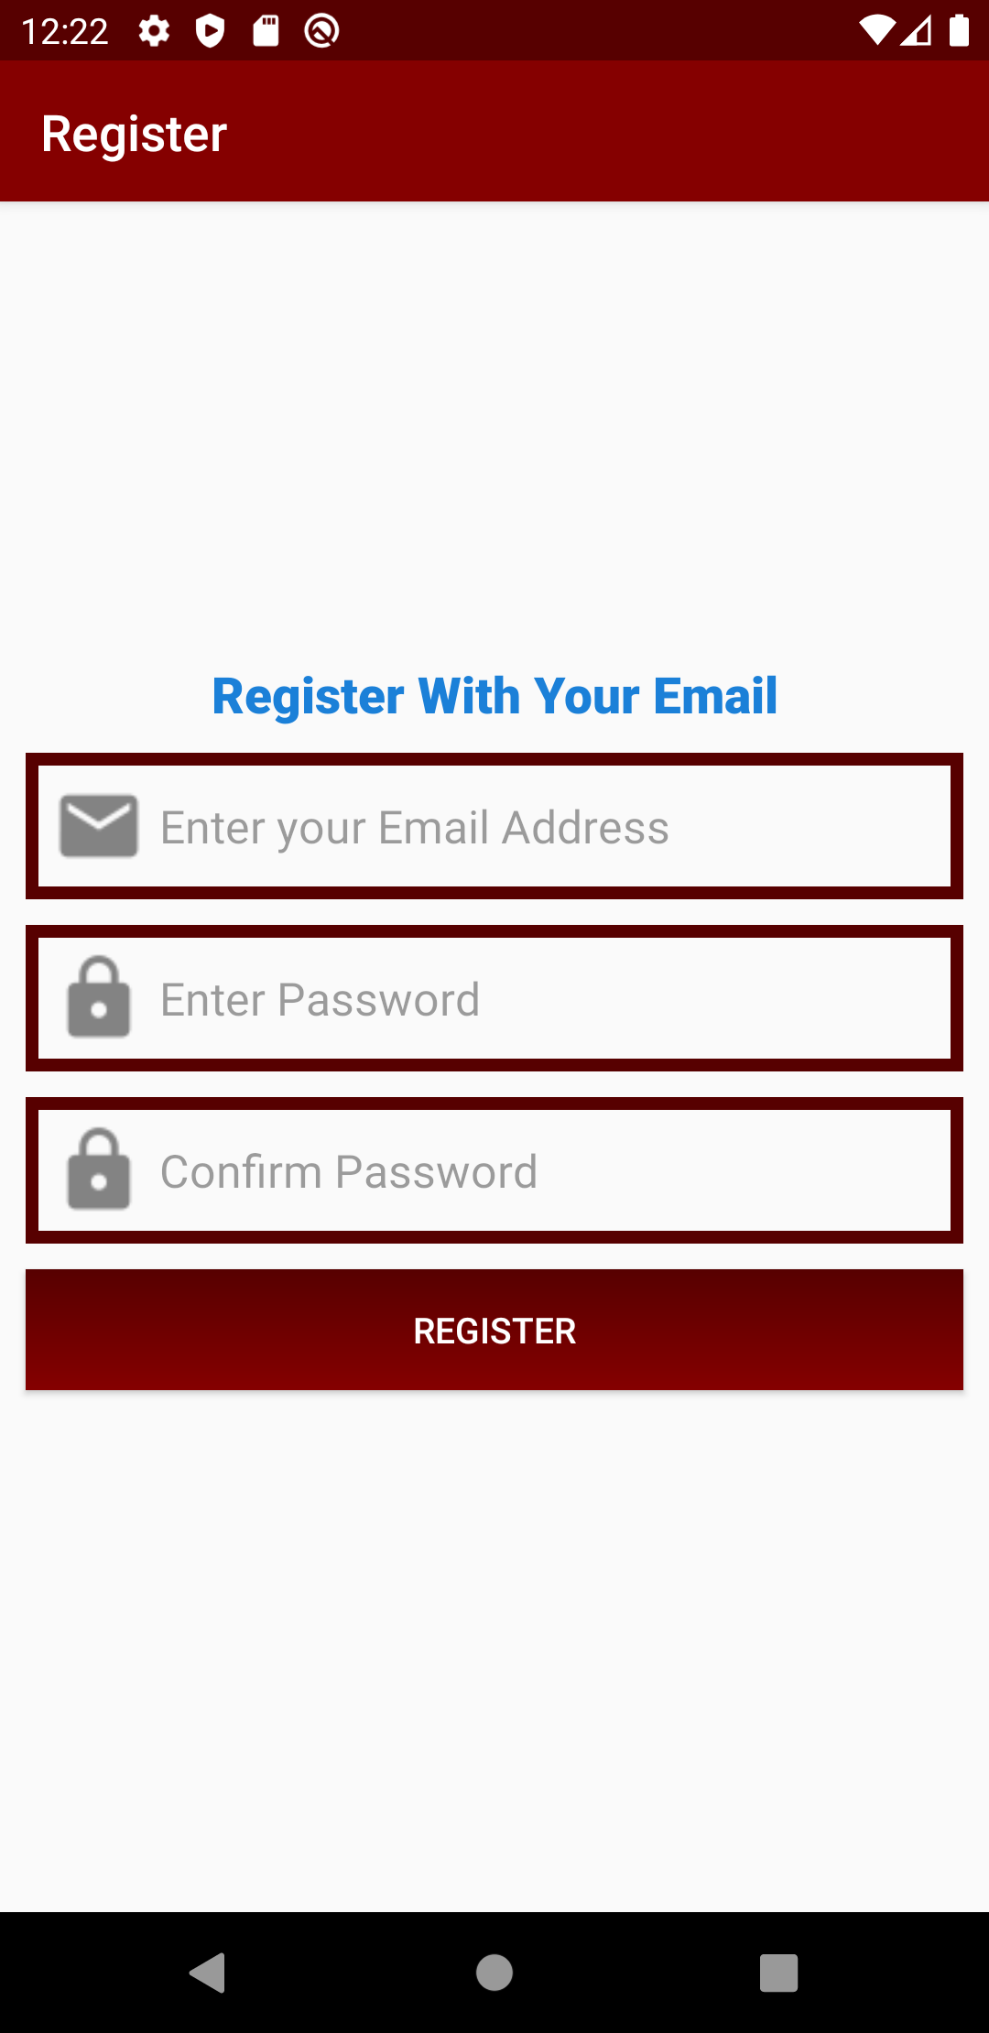

- Creating profile:
After authentication is completed, the app checks if the user has already created a profile or not. If no profile exists, it redirects the user to Create Profile activity. This activity has two tabs or fragments consisting two forms. One for patient type user, other for doctor type user. The user must fill up only one. By choosing which form to fill, the user type is automatically determined. In case of patient type user, the app takes patients name and age as direct input. In case of doctor, it takes name and qualification. For both users, a city field is also present but it is optional since the app determines it automatically using GPS. Upon submitting a form, the app attempts to take location of the user. If no permission was given prior to registration, the app prompts the user for location permission. The forms cannot be submitted if location permission is not granted. If the user accepts, the app collects latitude and longitude of the user using Geocoder. Finally, the information is sent to the database.

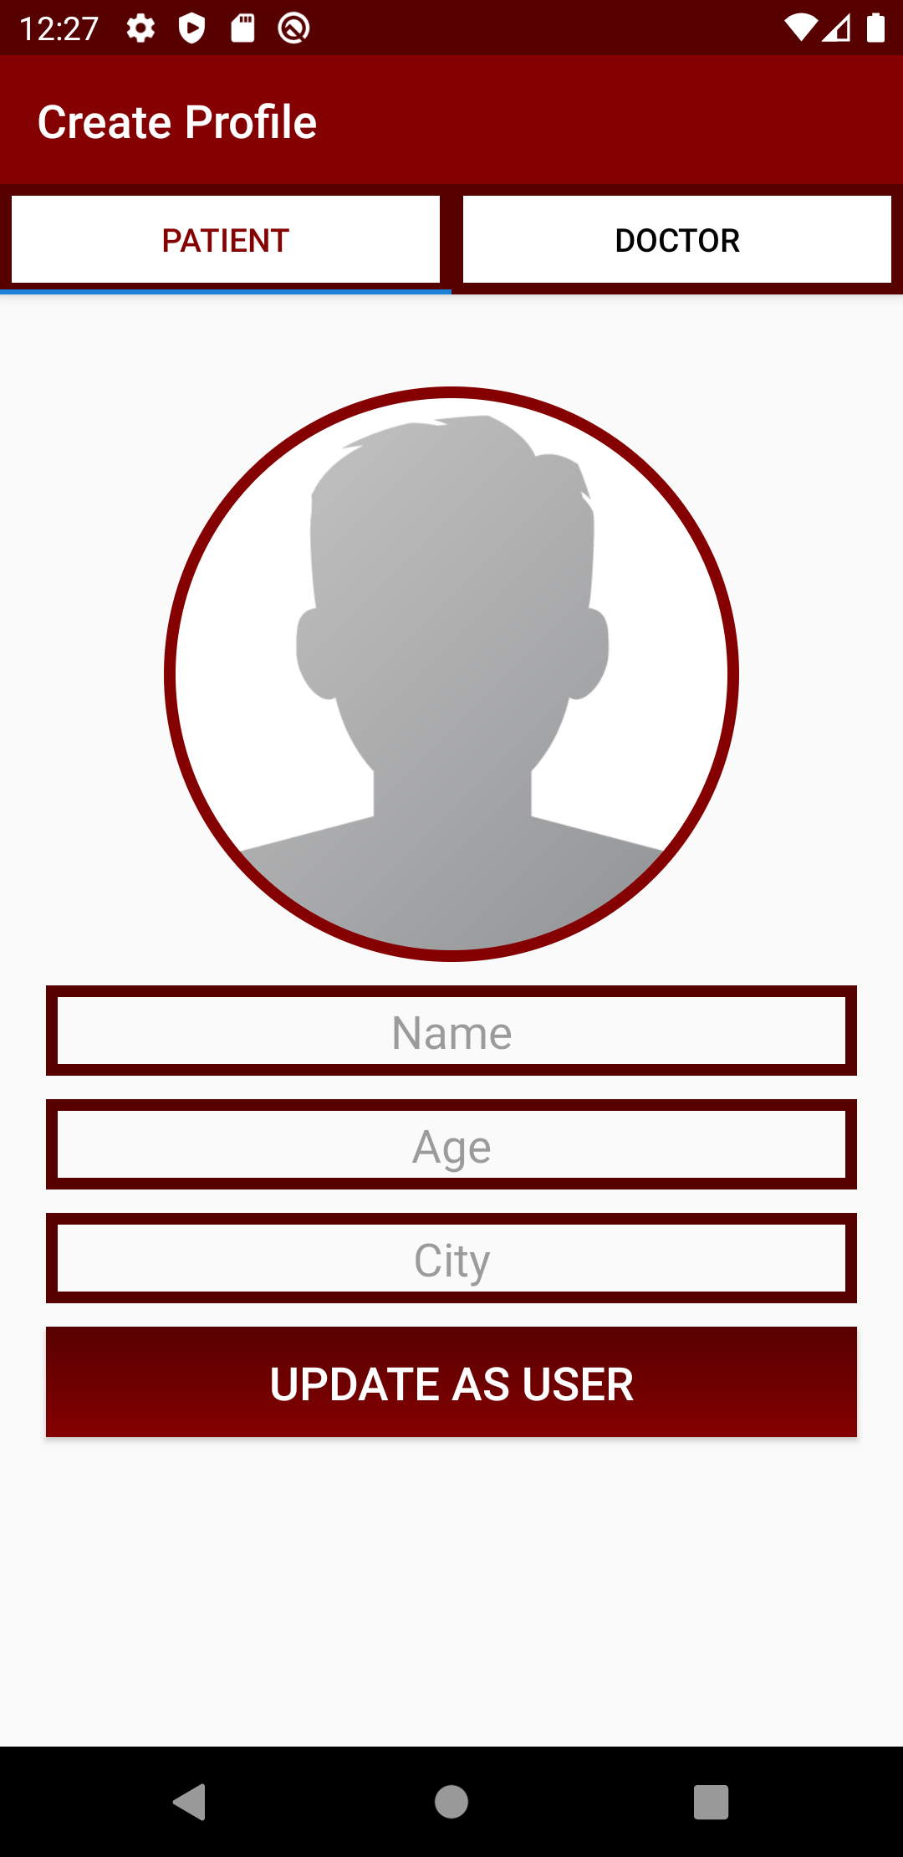

- Realtime Database:
The app is integrated with firebase and uses firebase auth and RTDB services. Because of it, all data can be updated and synced in Realtime.

- Finding nearby doctors:
Every time a user (doctor or patient) opens the app, their locations are updated in the RTDB. The find nearby doctors fragment initiates a query to the database to retrieve the ids of all doctors within 10km radius. It then resolves each id with doctor’s name and qualification using the database, and finally shows a list to the user along with each doctor’s approximate distance from the user’s location. The query is done using the Geofire library..
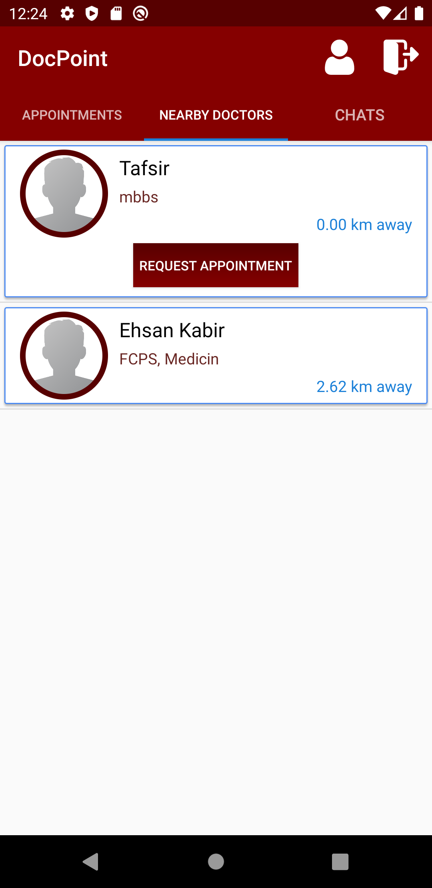

- Request for appointment:
From the presented list, user can request appointment to their chosen doctor.

- See all appointments:
In this fragment, the patient type users can see all of their appointments and their current status. If any appointment is accepted by the doctor, the option to chat with the doctor will be enabled.

- Communicate with doctor:
Patients can chat doctors who have accepted their request. The chat is updated in real-time

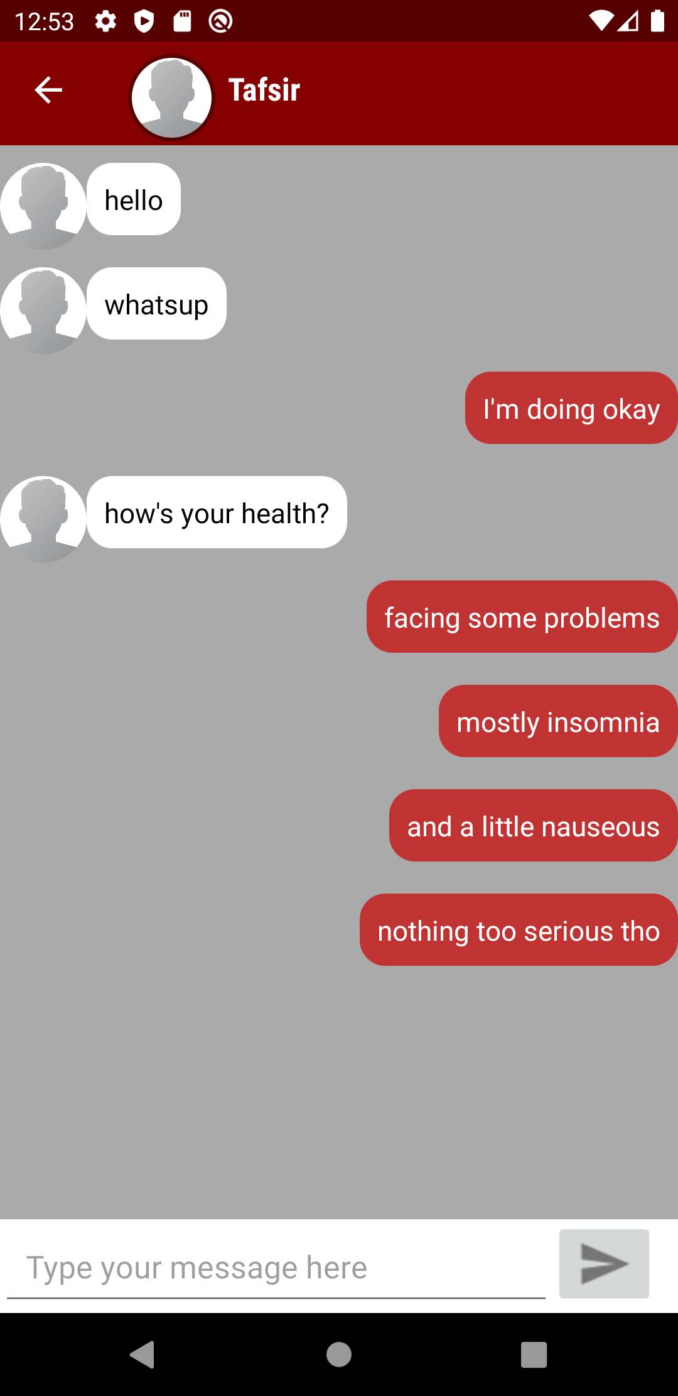

- See pending requests:
This fragment is part of the Doctor Activity. Information about all of the appointments is fetched from the database and filtered by their status. The pending appointments are grouped together and presented as a list along with the information about the patient and their approximate distance. The doctor can choose to either accept or reject the appointment to their liking.
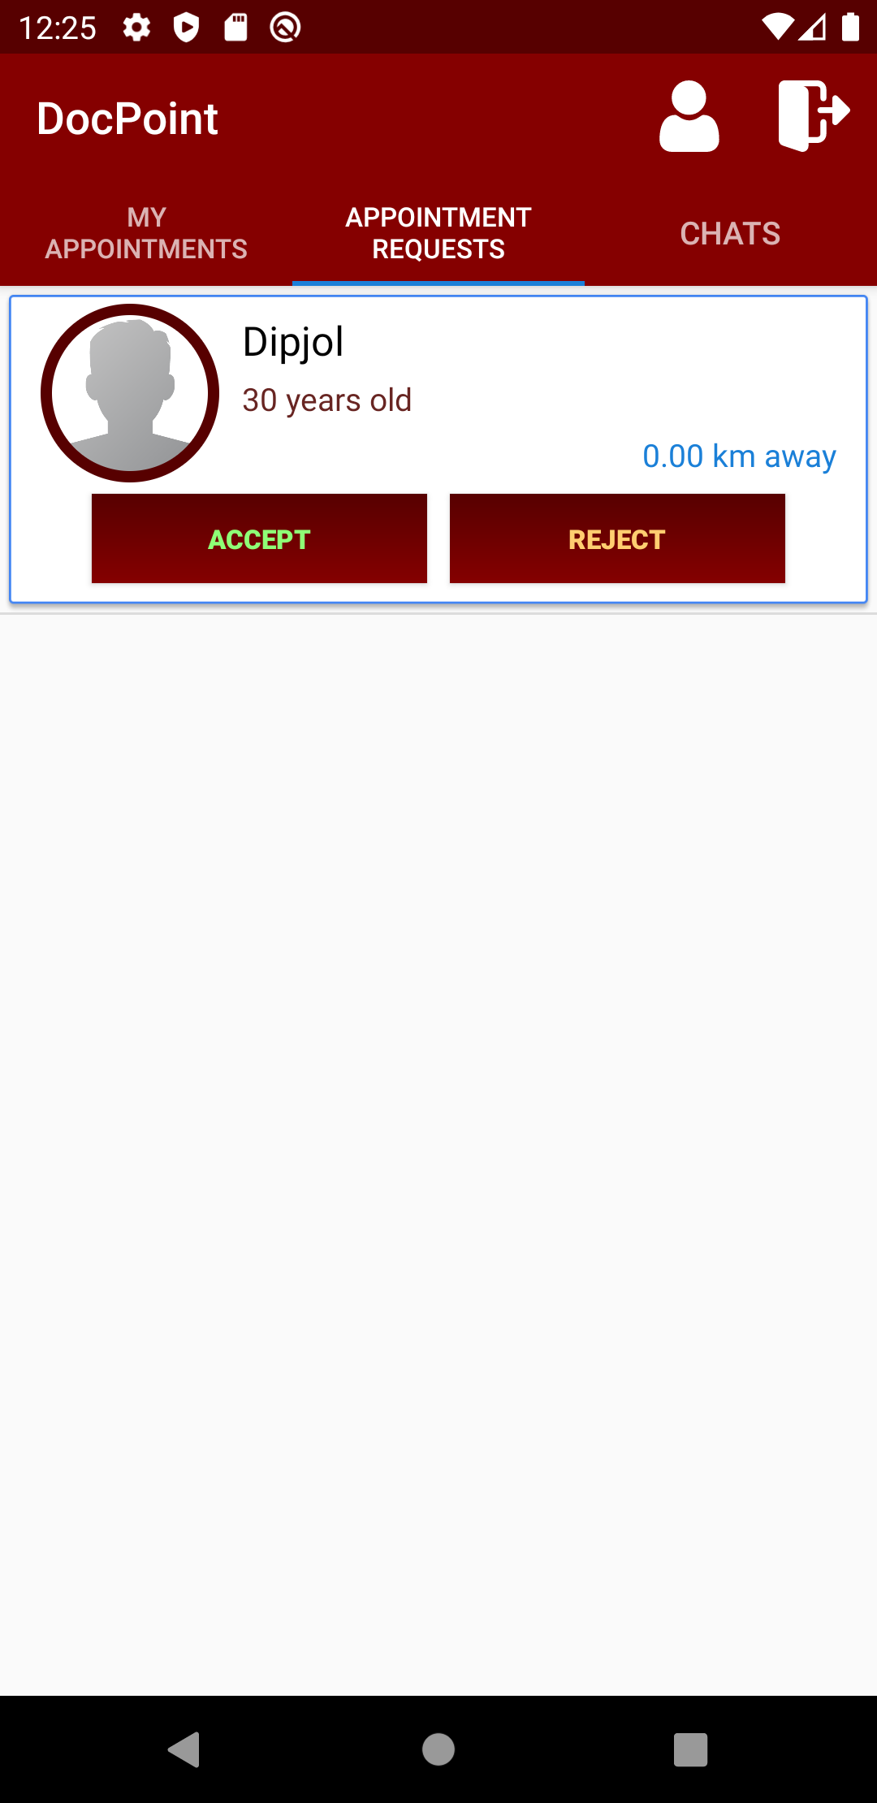

- Choose action for pending appointments:
The doctor can choose to either accept or reject the appointment to their liking.

- See active appointments:
This fragment presents all the appointments the doctor has accepted. Every list element has a chat button embedded to them which will take the doctor directly to the patient’s message inbox
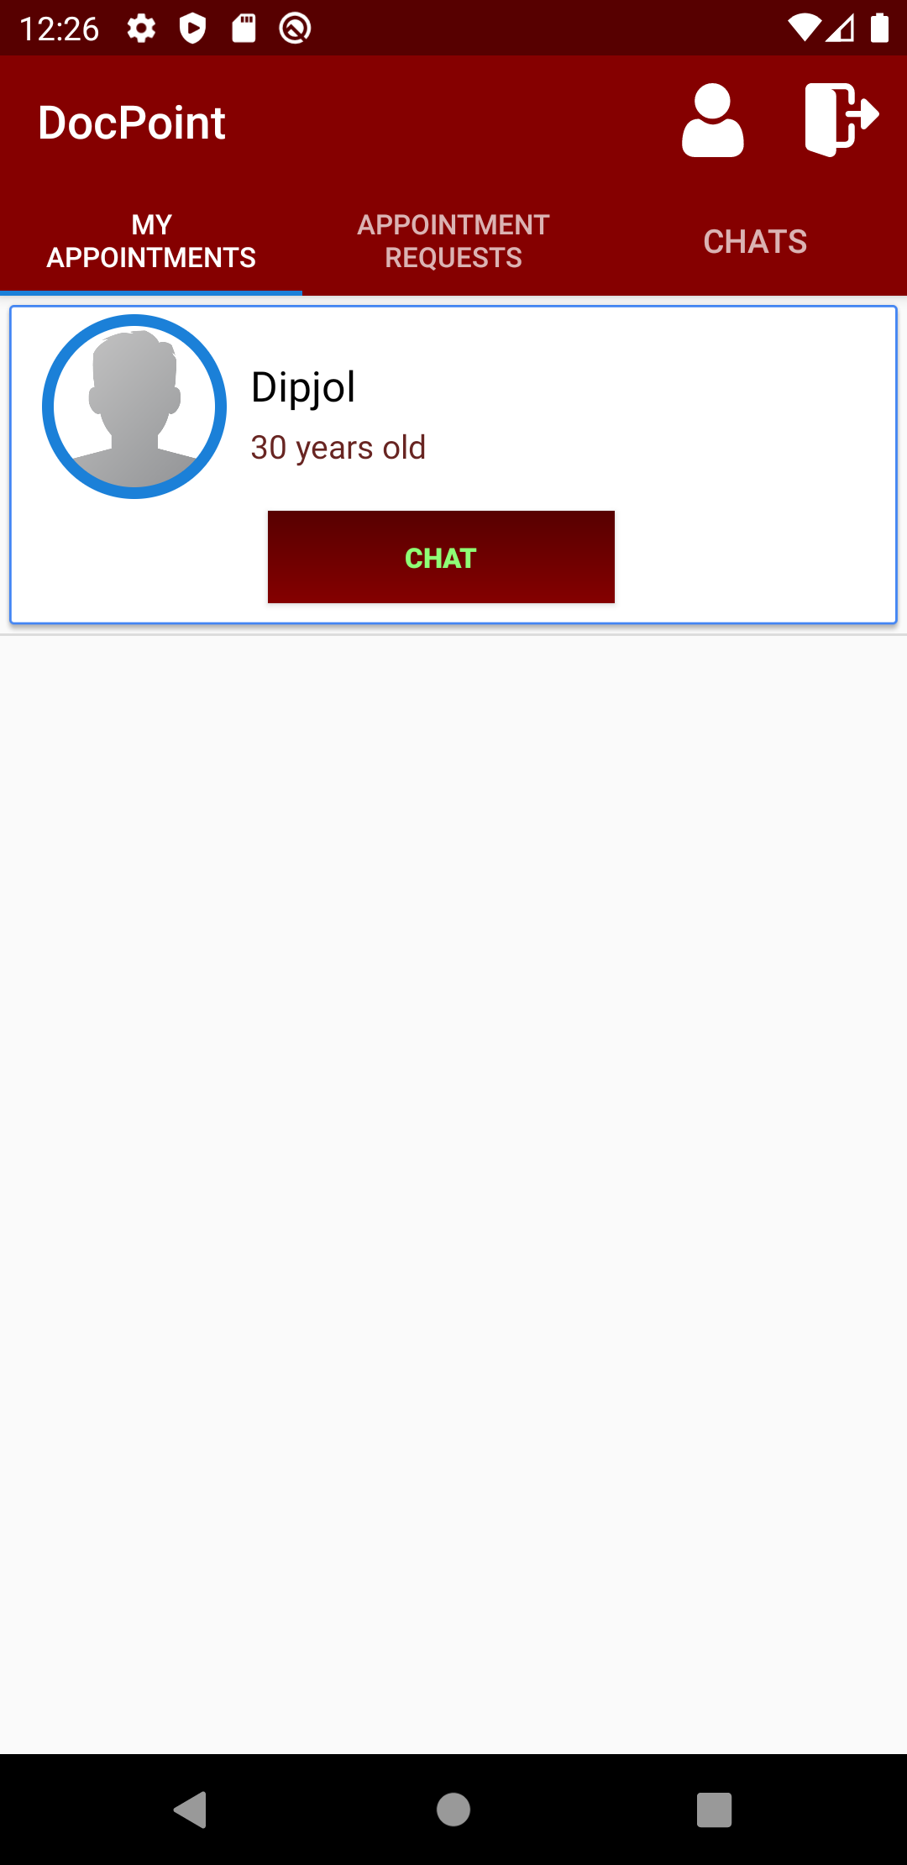

- Communicate with patients:
The doctor can chat with their patients. The chat is updated in real-time

- See chat history:
List of a user’s chats is presented in this activity. Tapping any element will take the user directly to that inbox
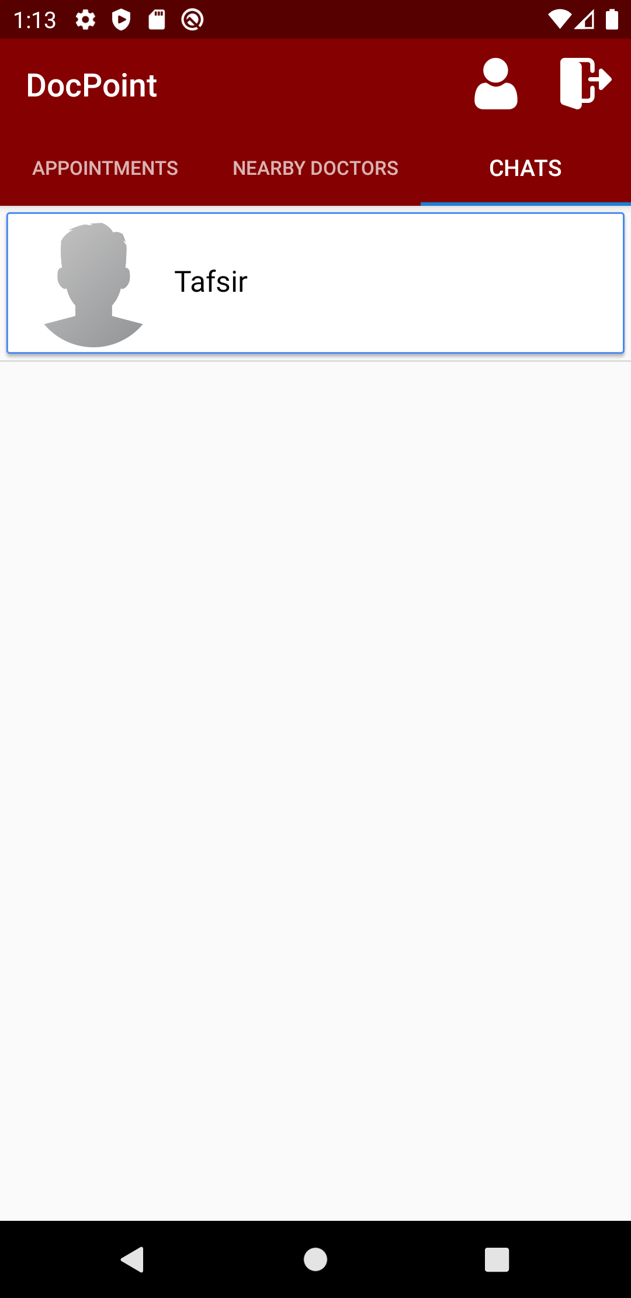

Online Resources used:
a) Reference:
- Chat function: https://www.youtube.com/playlist?list=PLxefhmF0pcPmtdoud8f64EpgapkclCllj
- Geofire: https://www.youtube.com/watch?v=-Bptl_MmwrQ
- Geocoder: https://www.youtube.com/watch?v=Ak1O9Gip-pg
b) Circle Image View: https://github.com/hdodenhof/CircleImageView

Future Enhancements:
Following enhancement can be added to the current system which will improve the system.
- Optimization
- Verification process
- Rating system
- Embedded payment system
- Enforcing information security
- Push Notification
- Extend capability

